CRUD APPLICATION

It is an app for storing user information for your business.

it has three pages :

1. LOGIN PAGE :

It has two input one for username and second one for password and also it has two buttons one for login and the second one for signup if you don’t have any account yet.

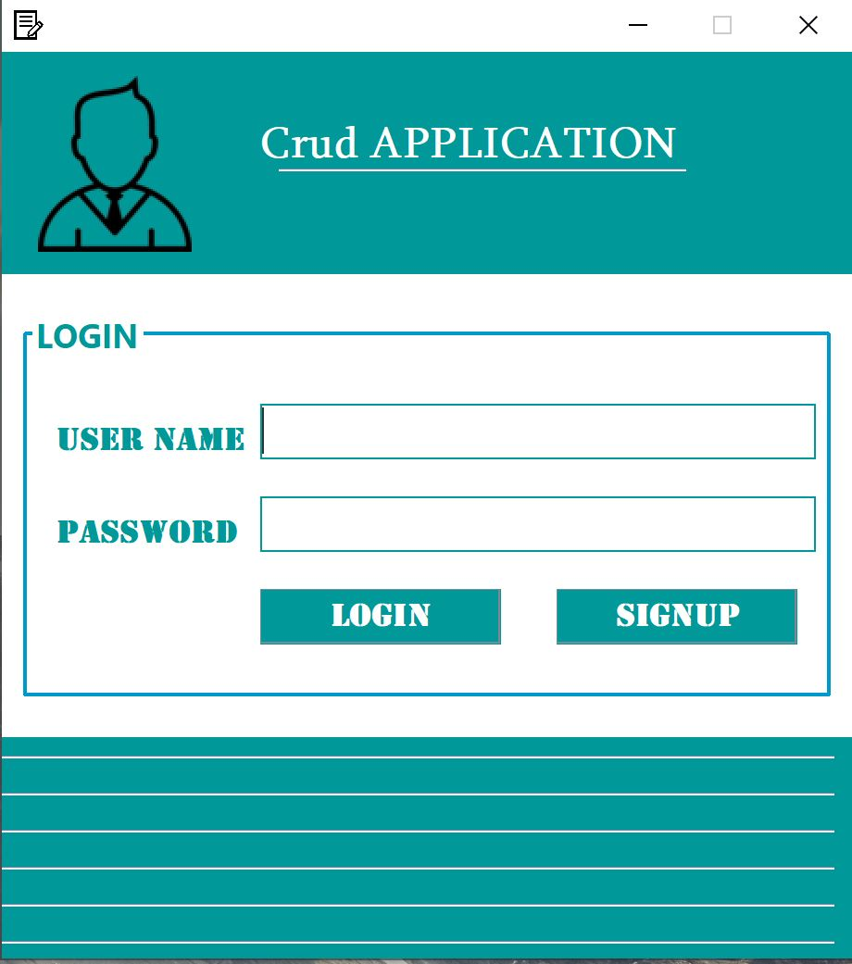

1. SIGNUP PAGE :

It has three input one for name second one for user name and the last one is the password for your user name and also it has two button one for signup and the second one is for backing to the login page

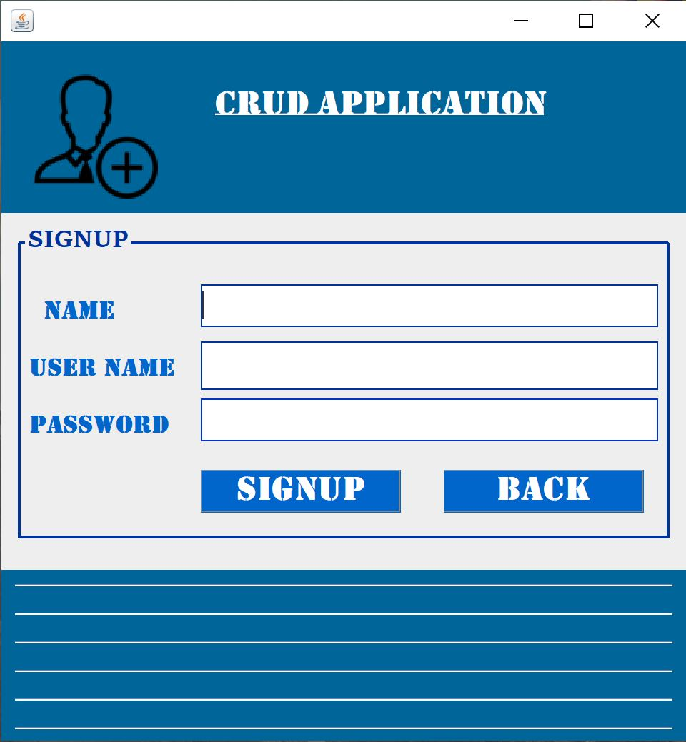

1. HOME PAGE :

It has three part :

* The registration form it has six input
* FIRST NAME
* LAST NAME
* GENDER
* CITY
* AGE
* ADDRESS
* BUTTONS
* INSERT: For registration.
* UPDATE : For changing the user information
* CLEAR : For making the inputs empty
* DELETE : For deleting the users
* The table for showing the users.
* Search input for finding the user that we want.

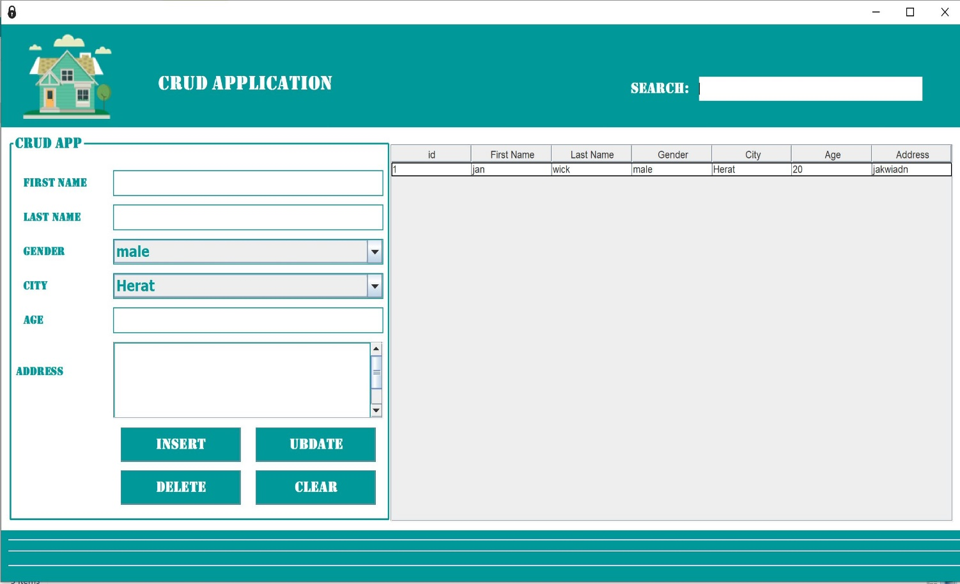

##### **Note : for running this project you should these steps**

1. Install the neat beans for opening this project
2. Install the WAMP or XAMP server in your pc or laptop
3. Make a database by the name of crudapp.

DEVELOPED By : JAWAD SADIQ , ID : S4040